# Sprint 4 Plan - Scrum Tools

## Revision 1 - 3/2/2024

## Sprint Completion - 3/9/2024

# Goal

In this sprint, we want to implement the feature of being able to add and remove sprints to the release plan.

# Spikes/Infrastructure

We might have to do some cleanup around the merging at the end of the last sprint, since different branches might not be immediately compatible. We also have to implement the repositories for each data model according to the sponsor’s request.

# Task Listing

### Story 1

| **Priority** | **Story** | **Acceptance Criteria** | **SP** |
| --- | --- | --- | --- |
| 1 - Must | As a product owner, I want to add a new sprint to an editable release plan so that I can plan the sprints while making the release plan. | Can add a new sprint to the release plan.  Looks better  Can remove sprints  Can edit sprints | 3 |

### 

| **Tasks** | **Ideal Hours** |
| --- | --- |
| 1. Add features to delete sprints. | 2 |
| 1. Add features to add sprints. | 2 |
| 1. Reorder sprints | 5 |
| 1. Backend function to reorder sprints | 1 |
| 1. Backend function to delete sprints | 2 |

# Initial Task Assignment

| Team member | Initial Task |
| --- | --- |
| Edison | 1.1 |
| Tanya | Fix sanity check, then 1.3 |
| Arthur | 1.3 |
| Andrew | Fix merging errors, then 1.4 |
| Michael | 1.2, 1.3 |

# Initial Burnup Chart

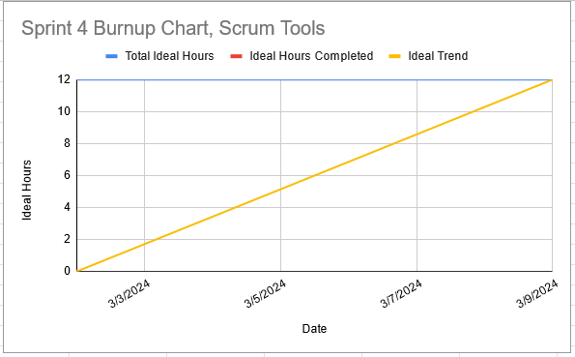

# Initial Scrum Board

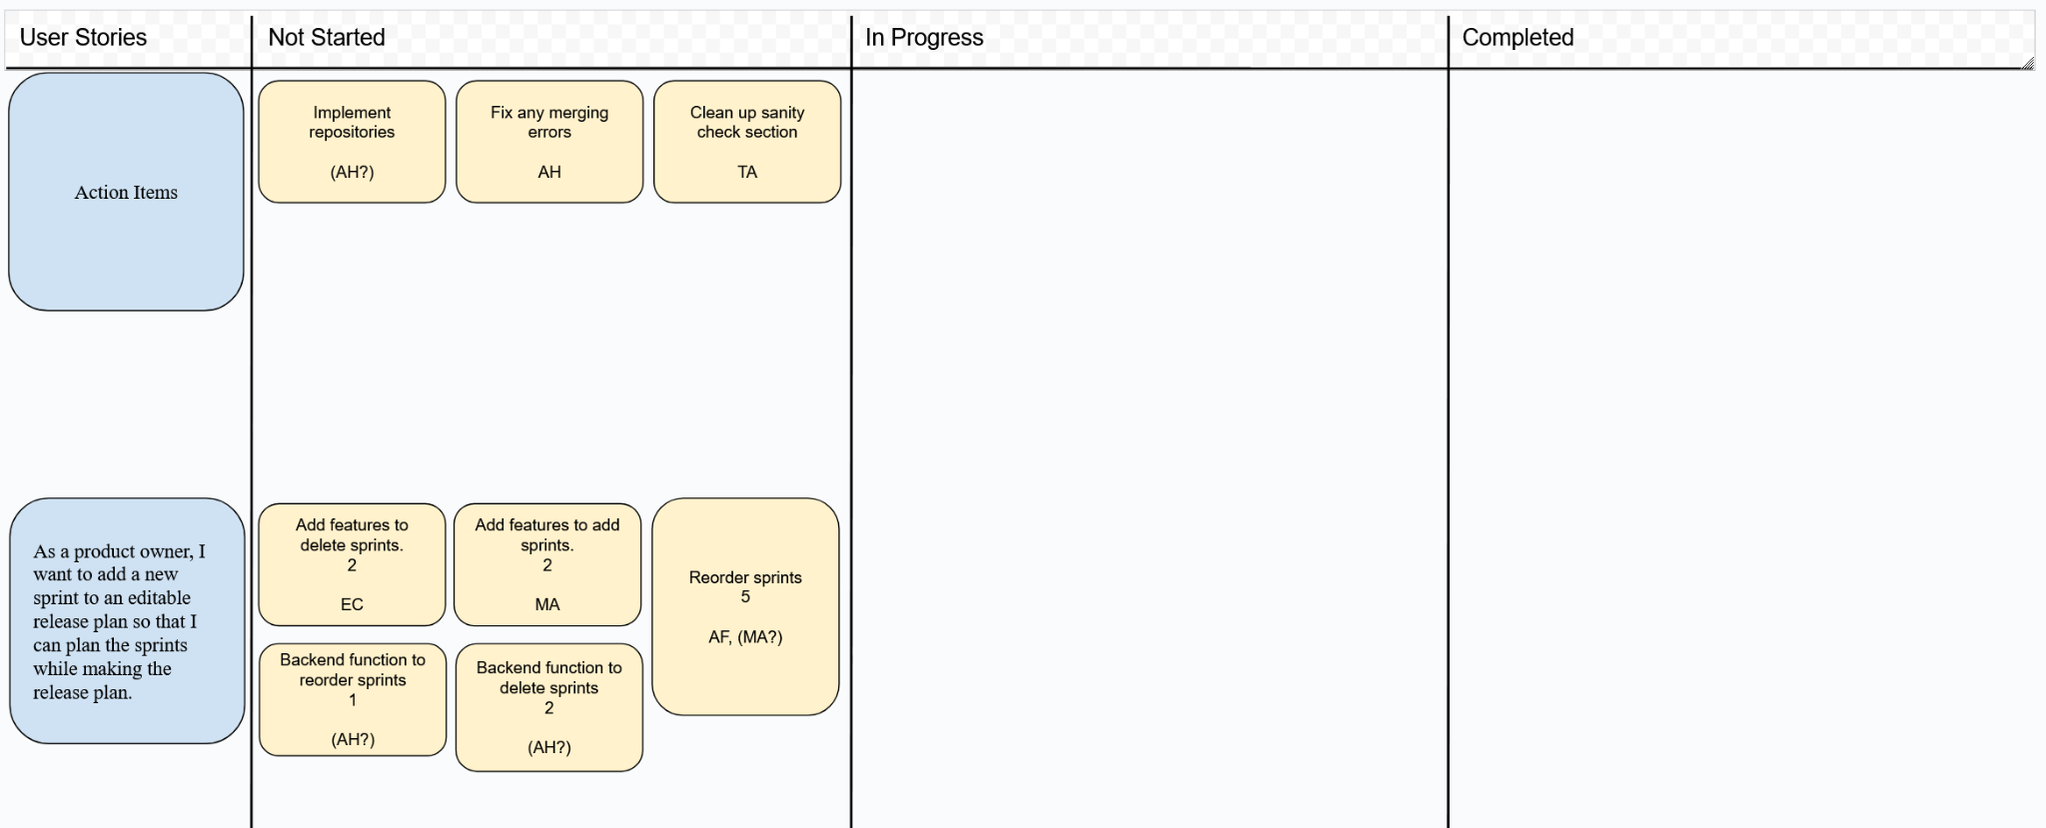

# Team Roles

| **Team member** | **Role(s)** |
| --- | --- |
| Edison | Frontend |
| Tanya | Frontend |
| Michael | Frontend |
| Andrew | Backend/Frontend |
| Arthur | Frontend |

# Scrum Times

Monday 1:15-2:00 pm (TA meeting)

Wednesday 1:15 pm

Saturday 1:15 pm

# Meeting Times

Frontend meeting: Monday Wednesday 2:00 pm - 3:00 pm

Backend meeting: Tuesday Thursday 12:00 pm - 1:00 pm

Design: Saturday After meeting until 3